

# Integrating ML Models for Automation

and Decision-making

Prepared By

SAKTHIVEL MURUGAN S



## Adaptive Environments based on User Behavior:

* Tailoring settings based on user behavior for a personalized experience.
* For example, adjusting lighting and temperature preferences based on daily routines.

Energy Optimization to Reduce Costs:

* Smart energy use by analyzing patterns, reducing costs, and consumption.
* For instance, optimizing heating and cooling schedules to minimize energy waste. Predictive Maintenance for Device Longevity:
* Predicting device maintenance needs for longevity and reliability.
* Such as identifying when a smart appliance requires maintenance before it

malfunctions.

Benefits:

* Personalized User Experience:
* Individualized smart home experience meeting specific preferences and adapting

to changing habits.

* E.g., adjusting settings in real-time as habits evolve.
* Increased Energy Efficiency:
* Optimized energy use for cost savings and sustainability.
* Leading to reduced energy bills and a more eco-friendly household.



* **Serverless Autoscaling:** Dynamically adjust function resources based on IoT data traffic, optimizing performance using machine learning models.
* **Serverless IoT Edge:** Combine serverless and edge computing for closer compute

resources, reducing latency and data transfer costs.

* **IoT State Management as a Service:** Develop a dedicated serverless state management service for real-time synchronization and scalability in IoT applications.
* **Serverless Security Middleware:** Integrate a serverless security middleware layer

for authentication, authorization, and encryption in IoT applications.

* **Multi-Cloud Serverless:** Create an abstraction layer for running IoT applications on multiple serverless platforms, ensuring vendor flexibility and failover.
* **Real-time Monitoring and Anomaly Detection:** Implement AI-driven anomaly detection for real-time monitoring in serverless IoT applications, enhancing system stability.
* **Federated Learning for IoT:** Apply federated learning to process IoT data locally on devices while preserving privacy and enabling global insights.
* **Hybrid Serverless-IoT Platforms:** Seamlessly integrate serverless and IoT capabilities into a unified platform for efficient application development.

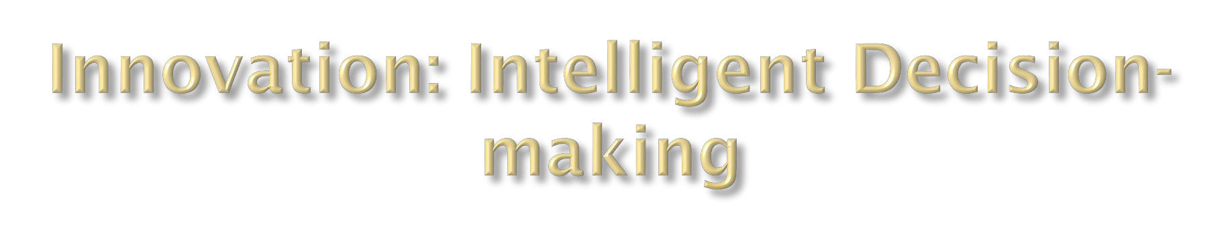

## Augmented Security through Behavioral Analysis:

* + Utilizing behavioral analysis to enhance security measures.
  + For example, detecting unusual patterns and potential security threats.

## Health Monitoring and Assistance:

* + Providing health monitoring and immediate assistance through connected devices.
  + Such as monitoring vital signs and detecting emergencies, triggering

appropriate responses.

## Benefits:

* **Enhanced Safety and Security:**
  + Proactive security measures based on behavioral analysis, ensuring a secure

living environment.

* + E.g., immediate alerts for unusual activities enhancing overall safety.

## Proactive Health Monitoring and Assistance:

* + Continuous health monitoring, ensuring timely responses to potential health issues.
  + Leading to a more proactive approach to healthcare within the home.



## Challenges:

* **Data Privacy and Security:**
  + Safeguarding sensitive user data from potential breaches.
  + Ensuring compliance with privacy regulations and standards.

## Algorithmic Accuracy and Robustness:

* + Enhancing accuracy and robustness of machine learning algorithms.
  + Mitigating false positives/negatives for reliable automation.

## Interoperability and Integration:

* + Ensuring seamless integration of diverse devices and platforms.
  + Promoting interoperability for a cohesive smart home ecosystem.

## Benefits and Future Prospects:

* **Improved Efficiency and Sustainability:**
  + Optimizing resource usage and energy consumption for a greener footprint.
  + Streamlining routines and device usage for overall improved efficiency.

## Resource Optimization:

* + Smartly allocating resources based on usage patterns and real-time needs.
  + Reducing wastage and enhancing the lifecycle of devices.



* **Integration of Innovations:** By blending machine learning, edge computing, blockchain, and AI, we unlock immense potential to revolutionize serverless IoT applications.
* **Overcoming Challenges**: These innovations address critical challenges, including latency, security, scalability, and cost, paving the way for robust IoT ecosystems.
* **Tailored Solutions:** Depending on specific use cases, adopting one or more of these solutions can optimize operations, enhance security, and ensure efficient resource allocation.
* **Future Prospects:** The future of IoT lies in continued exploration and integration of emerging technologies, pushing the boundaries of what's possible in the connected world.
* **Collaboration and Growth:** Collaborative efforts and an open mindset towards innovation will drive the evolution of IoT, creating a smarter, more connected, and sustainable future.